AIM: To learn:

* + to display text “Hello World” on screen using GUIText

**Preparation/Setup**

* Create a new, empty Unity project
* Create folder “Scenes”, to store your scenes
  + Save into this folder the current (empty) scene as “scene1”
* Create folder “Fonts”
  + Import into this folder the provided font “DROPCAPS.TTF”

**Notes**

* Your project after setup should look as follows:

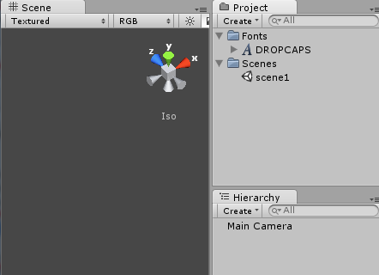

# Create a new GUITexture based on the selected image

Do the following:

* Create a new GUI Text

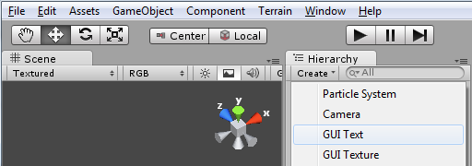

# Change default text to “Hello World”

Do the following:

* Change the default text “GUI Text” to “Hello World”

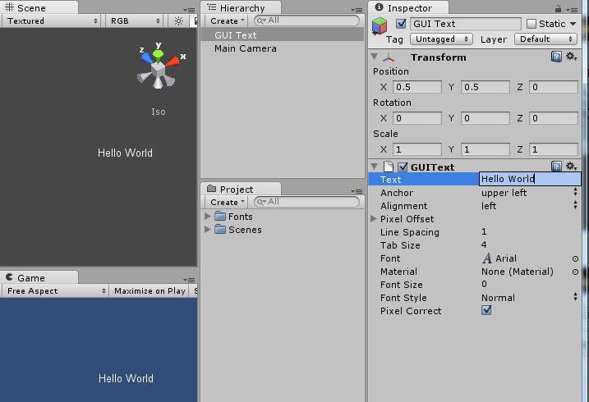

# Save and run your program

Do the following:

* Save your work (i.e. the scene)
* Run the game
* you should now see your text message running in the Game panel

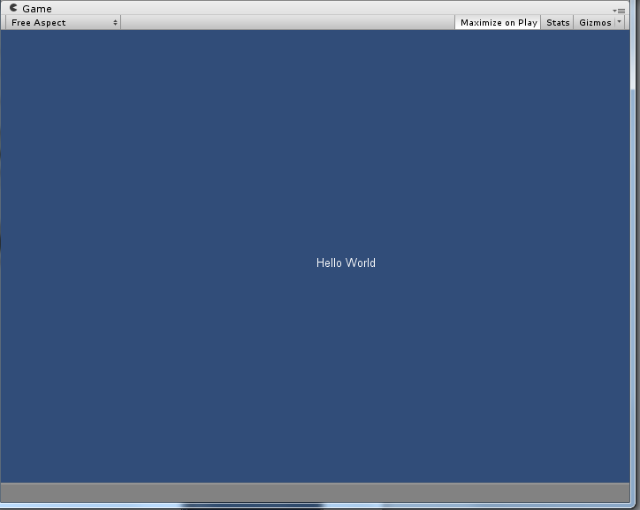

# Change font and font text size

Do the following:

* Change font from default to “DROPCAPS.TTF”
* Make Font Size laerger (e.g. try 75) and reposition GUIText so it fits the screen
* you should now see your text message in the nice large font letters…

